PROJECT REPORT OF INDUSTRY ORIENTED HANDS ON EXPERIENCE (IOHE)

On
Employee Management System
submitted in partial fulfilment of the requirements for the award of degree of
BACHELOR OF ENGINEERING
In
COMPUTER SCIENCE AND ENGINEERING

Submitted By:  - Ankesh Kumar (2211985007)  - Ankit Thakur (2211985008)  - Bhavneesh Sharma (2211985015)  - Tarun Rana (2211985052) | Supervised By:  Dr. Rajat Takkar (9467026112)  (rajat.takkar@chitkara.edu.in)  (CET 1004342)  Assistant Professor  Chitkara University, Rajpura



DEPARTMENT OF COMPUTER SCIENCE AND ENGINEERING
CHITKARA UNIVERSITY INSTITUTE OF ENGINEERING AND TECHNOLOGY CHITKARA UNIVERSITY, PUNJAB, INDIA

CONTENTS

S.No. Title Page No.

Acknowledgement iv Abstract v
1. Introduction to Project 6
2. Methodology 8
3. Design 11
4. Implementation and Results 13
5. Coding 15
6. Prototype Photographs for User Side 16
7. Conclusion and Future Work 18

DECLARATION
I hereby certify that the work which is being presented in the project report entitled Employee Management System in partial fulfilment of requirement for the award of the degree of Bachelor of Engineering (Computer Science and Engineering) submitted in the department of Computer Science and Engineering at Chitkara University Institute of Engineering and Technology, Chitkara University, Punjab, India, is an authentic record of my own work carried out under the supervision of Dr. Rajat Takkar. The matter presented in this project report has not been submitted in any other university/institute for the award of any degree.
Place: Rajpura  Date: 16-05-2026 | Ankesh Kumar  University Roll No: 2211985007

This is to certify that the above statement made by the candidate is correct to the best of my knowledge and belief.

Dr. Rajat Takkar
Assistant Professor
Department of Computer Science and Engineering
Chitkara University Institute of Engineering and Technology,
Chitkara University, Punjab, India

ACKNOWLEDGEMENT

I would like to express my sincere gratitude to the Department of Computer Science and Engineering for providing me the opportunity to work on this project, Employee Management System. The support, encouragement, and academic environment provided by the department played an important role in the successful completion of this work. The knowledge gained during the course of study and the guidance received from the department helped me develop a clear understanding of the concepts required for this project.
I would also like to thank all the faculty members of the department for sharing their valuable knowledge and for providing continuous academic support throughout the duration of this project. Their lectures, suggestions, and discussions helped strengthen the technical understanding necessary for designing and implementing this system.
I express my heartfelt gratitude to my project guide, Dr. Rajat Takkar, for her valuable guidance, constant encouragement, and support throughout the development of this project. Her suggestions and motivation helped me improve the quality and functionality of the system and successfully complete the project work.
I am grateful to Chitkara University for providing the required facilities, resources, and infrastructure that made the development of this project possible. The availability of laboratories, technical resources, and a supportive learning environment allowed me to work effectively and gain practical experience in frontend development, backend development, RESTful APIs, authentication systems, and database management.
I would also like to acknowledge the support and cooperation of my classmates and friends whose ideas, discussions, and teamwork contributed significantly to the successful completion of this project. Their support helped in solving technical challenges and improving the overall implementation of the system.
Special thanks are also extended to the technical staff and laboratory assistants who helped provide access to the required systems and resources whenever needed. Their assistance during the development and testing phases was greatly appreciated.
Finally, I would like to thank my family for their constant encouragement, motivation, and moral support throughout the development of this project. Their understanding and support helped me remain focused and dedicated toward achieving this milestone successfully.
I sincerely acknowledge and appreciate everyone who contributed directly or indirectly to the successful completion of this project. Their support and encouragement played a significant role in completing this work successfully.

ABSTRACT

Employee Management System is a full-fledged web application designed to simplify and automate employee-related processes in an organization. The main goal of this system is to offer a single, digital platform for the efficient and secure handling of employee information. Paper files or spreadsheets, used in traditional methods of employee record management, often lead to duplicate data, errors and problems in retrieving information. The project aims to solve these problems by providing a modern, web-based solution.
The system comprises a frontend interface, a backend server and a database that work together in a client-server architecture. Easy to use dashboard for administrators to add, update, delete and view employee records. The staff can login securely and check their salary details and apply leave online. The leave management feature makes it easier for managers to review, approve or deny leave requests, helping to make communication and workflow transparency within the organization more efficient. The backend handles business logic, authentication and API integration. A scalable NoSQL database like MongoDB is employed to store and manage employee data securely. The system provides data accuracy, quick retrieval and enhanced security over the traditional methods.
In addition, the system supports role-based access control, ensuring that only authorized users can access sensitive information. Automated notifications and email alerts help employees and managers stay updated regarding leave requests, salary updates, and important announcements. The application is designed with a responsive user interface, allowing users to access the system easily from desktops, tablets, and mobile devices. Advanced search and filtering options also improve the efficiency of managing employee records and generating reports.
This project is a good example of the practical skills in full stack development such as front end design, backend development, RESTful API implementation, and database integration. In conclusion, the Employee Management System improves productivity, decreases the administrative burden, and offers an effective digital solution for workforce management in today’s organisations.

1. Introduction to Project

1.1 Project Background
In today’s digital era, organizations are increasingly adopting automated systems to improve efficiency, accuracy, and productivity in managing their workforce. Traditional employee management methods, which rely on paper records or spreadsheets, are often time-consuming, difficult to maintain, and prone to errors such as data duplication, loss of information, and delayed retrieval of records. As companies grow, handling employee details manually becomes more challenging and inefficient. Therefore, there is a strong need for a centralized and secure system that can effectively manage employee-related activities.
The Employee Management System is developed as a web-based application to overcome these challenges and modernize workforce management. The system provides a single digital platform where employee information can be stored, updated, and accessed easily. It helps administrators manage employee records efficiently while reducing manual paperwork and administrative workload. Employees can securely log into the system to view salary details, update personal information, and apply for leave online. Managers can also review and approve leave requests, making communication faster and more transparent within the organization.
The project follows a client-server architecture consisting of a frontend interface, backend server, and database. The frontend provides a user-friendly dashboard for interaction, while the backend handles business logic, authentication, and API communication. A NoSQL database such as MongoDB is used to securely store and manage employee data. By integrating modern web technologies, the system ensures data accuracy, quick retrieval, improved security, and scalability. Overall, the Employee Management System serves as an efficient digital solution that enhances organizational productivity and demonstrates practical implementation of full stack web development concepts.

1.2 Problem Statement
Managing employee information manually through paper records or spreadsheets is a difficult and time-consuming process for organizations. Traditional methods often result in data redundancy, errors in record maintenance, difficulty in retrieving information, and lack of proper security. As the number of employees increases, handling attendance, salary details, and leave requests becomes more complex and inefficient. Communication between employees, administrators, and managers may also become slow due to the absence of a centralized system.
Another major issue with manual employee management is the risk of data loss and unauthorized access to sensitive employee information. Updating records frequently requires significant administrative effort, which reduces productivity and increases the chances of human error. In addition, employees face inconvenience in applying for leave or checking salary details because these tasks usually depend on manual approval processes and physical documentation.
To overcome these challenges, there is a need for a secure, reliable, and automated Employee Management System that can efficiently manage employee records, streamline administrative tasks, and improve communication within the organization. The proposed system aims to provide a centralized web-based platform where administrators can manage employee data, employees can access their information securely, and managers can process leave requests efficiently. This system will help reduce paperwork, improve data accuracy, enhance security, and increase overall organizational productivity.

1.3 Objective of the Project
- To develop a centralized platform for managing employee information efficiently.
- To reduce the use of manual paperwork and spreadsheet-based record keeping.
- To maintain accurate and up-to-date employee records in a secure database.
- To simplify the process of adding, updating, deleting, and viewing employee details.
- To provide secure login and authentication for administrators and employees.
- To improve data security and prevent unauthorized access to sensitive information.
- To automate leave application and leave approval processes.
- To enable employees to view their salary details, attendance, and personal information online.
- To reduce data duplication and human errors in employee management.
- To improve communication between employees, managers, and the HR department.
- To provide quick and easy retrieval of employee records whenever required.
- To generate reports related to employees, attendance, salaries, and leaves efficiently.
- To increase organizational productivity by automating repetitive administrative tasks.
- To create a user-friendly and responsive web interface for better accessibility.
- To support role-based access control for different types of users in the system.
- To store and manage employee data securely using a database like MongoDB.
- To improve transparency in leave management and employee-related workflows.
- To minimize administrative workload and save time for HR departments.
- To provide scalability so the system can handle a growing number of employees.
- To implement modern full-stack development concepts such as frontend design, backend APIs, and database integration.

1.4 System Overview
The recommended solution consists of a fully functional web-based Employee Management System whose purpose is to streamline and automate processes involving employee record management in an organization. This software solution presents an effective digital tool to substitute manual approaches to working with employee data. The Employee Management System is constructed in such a way that ensures easy and efficient cooperation between the system and its users by means of the frontend interface, the backend server and the database.
The frontend is built based on web development technologies and makes it possible for users to work with multiple system modules with ease. The backend server serves to process and authenticate data from users while communicating with the database. Moreover, the application allows transferring data between the frontend and backend through RESTful APIs.
The system facilitates the implementation of CRUD (Create, Retrieve, Update, Delete) operations effectively for administrative purposes. Administrators will be able to create new employee entries, update the information on an existing employee record, read or view an employee’s profile, and delete unnecessary employee records. Employee profiles may contain full information about an employee, including his/her personal information, job designation, department, contact details, and work experience.
A client-server architecture underlies the application design. It ensures high performance and scalability of the application. The application will be able to process and retrieve employee data more effectively due to its client-server nature. The use of a scalable database such as MongoDB supports efficient management of both structured and unstructured data.
In addition, the system provides secure authentication and authorization mechanisms to ensure that only authorized users can access confidential employee information. Employees can securely log in to view their salary details, attendance records, and leave status, while administrators can manage employee activities efficiently. The leave management module allows employees to apply for leave online and enables managers to approve or reject requests digitally, reducing paperwork and saving time. The responsive web interface also allows users to access the system through computers, tablets, and mobile devices. Overall, the proposed solution improves organizational efficiency, enhances data accuracy, reduces administrative workload, and supports better communication and transparency within the workplace.

1.5 Expected Benefits
The Employee Management System provides several benefits to organizations by improving the efficiency and accuracy of employee-related operations. One of the major benefits of the system is centralized data management, where all employee information is stored securely in a single database. This reduces the use of paper files and manual record keeping, helping organizations save time, space, and operational costs. The system minimizes human errors and data duplication, ensuring accurate and up-to-date employee records. It also allows quick retrieval of employee information whenever required, improving overall productivity and workflow efficiency.
Another important benefit is enhanced security and transparency. Through secure login authentication and role-based access control, confidential employee information remains protected from unauthorized access. Employees can easily view their profiles, attendance, salary details, and leave status online, while managers can monitor employee activities and approve leave requests efficiently. This improves communication between employees, managers, and the HR department while maintaining transparency in organizational processes.
The system also reduces administrative workload by automating tasks such as attendance management, leave processing, and report generation. Being a web-based application, it can be accessed from different devices and locations, providing flexibility and convenience to users. Furthermore, the use of modern technologies and scalable databases like MongoDB ensures better performance, scalability, and reliable data storage. Overall, the Employee Management System improves organizational productivity, enhances data security, saves time, and provides an effective digital solution for workforce management.

2. Methodology
The methodology followed for the development of the Employee Management System involves a systematic approach to designing, developing, testing, and implementing the application. The project is developed using full stack web technologies with a client-server architecture to ensure efficient communication between the frontend, backend, and database.
The first step in the methodology is requirement analysis, where the problems of traditional employee management systems are identified. The system requirements such as employee record management, secure login, leave management, salary details, and database storage are carefully analyzed. Based on these requirements, the overall system design and workflow are planned.
In the design phase, the architecture of the application is created. The frontend interface is designed to provide a user-friendly experience for administrators and employees. Technologies such as HTML, CSS, JavaScript, and modern frontend frameworks are used to build responsive web pages. The backend is developed to handle business logic, authentication, and API communication using server-side technologies. RESTful APIs are implemented for smooth data exchange between the frontend and backend.
The database design phase includes creating collections and schemas in MongoDB to store employee-related information securely. The database manages employee details, attendance, salary records, and leave applications efficiently. CRUD operations are implemented to allow administrators to create, retrieve, update, and delete employee records.
After development, the system undergoes testing to identify and fix errors. Functional testing, authentication testing, and database testing are performed to ensure that all modules work correctly.

2.1 System Approach
The Employee Management System follows a client-server approach to manage employee-related activities efficiently through a centralized web-based platform. The system is designed to automate manual processes and provide secure, fast, and accurate management of employee information. The overall approach focuses on integrating the frontend, backend, and database into a single system that allows smooth communication and efficient data processing.
The frontend of the system acts as the user interface through which administrators, managers, and employees interact with the application. It is developed using modern web technologies to provide a responsive and user-friendly environment. Users can perform tasks such as logging in, viewing employee details, applying for leave, checking salary information, and managing records through the interface.
The backend server is responsible for handling the business logic of the application. It processes user requests, validates input data, performs authentication, and communicates with the database. RESTful APIs are used to establish communication between the frontend and backend, ensuring secure and efficient data transfer. The backend also manages important operations such as employee registration, attendance management, leave approval, and report generation.
MongoDB is used as the database system to store and manage employee information securely. The database stores records such as employee profiles, department details, salaries, attendance, and leave history. Since MongoDB is a scalable NoSQL database, it can efficiently handle both structured and unstructured data while supporting future expansion of the system.
The system also follows a role-based access approach where different users have different permissions. Administrators have full control over employee management operations, managers can monitor employee activities and approve leave requests, while employees can access their own information securely. Security features such as password encryption and authentication mechanisms are implemented to protect sensitive data from unauthorized access.
Overall, the system approach ensures centralized data management, automation of administrative tasks, improved communication, enhanced security, and better organizational efficiency through a reliable web-based solution.

2.2 Tools and Technologies
The following technologies were used to develop the Employee Management System platform.

- HTML – Used to create the structure of the web pages.
- CSS – Used for styling and designing the user interface.
- JavaScript – Adds interactivity and dynamic functionality to the application.
- React.js – Frontend library used for building responsive and reusable UI components.
- Node.js – Server-side runtime environment used to execute backend code.
- Express.js – Backend framework used to build APIs and manage server operations.
- MongoDB – NoSQL database used to store employee records and application data.
- Mongoose – Used for database modeling and interaction with MongoDB.
- JWT (JSON Web Token) – Used for secure authentication and authorization of users.
- GitHub – Platform used for version control and project repository management.

2.3 Flow of the System
The flow of the Employee Management System begins with secure user authentication, where administrators, managers, and employees log in using their credentials. After successful login, users are redirected to their respective dashboards based on their roles and permissions. The administrator can manage employee records by performing operations such as adding, updating, viewing, and deleting employee information. When a user performs any action, the frontend sends requests to the backend server through RESTful APIs. The backend processes these requests, validates the data, and communicates with the MongoDB database to store or retrieve information. Employees can access their profiles, view salary details, attendance records, and apply for leave online. Managers or administrators can review and approve or reject leave applications through the system. Finally, the system generates reports and displays updated employee information efficiently, ensuring smooth workflow, secure data management, and effective communication within the organization.

3. Design
3.1) Use Case Diagram:

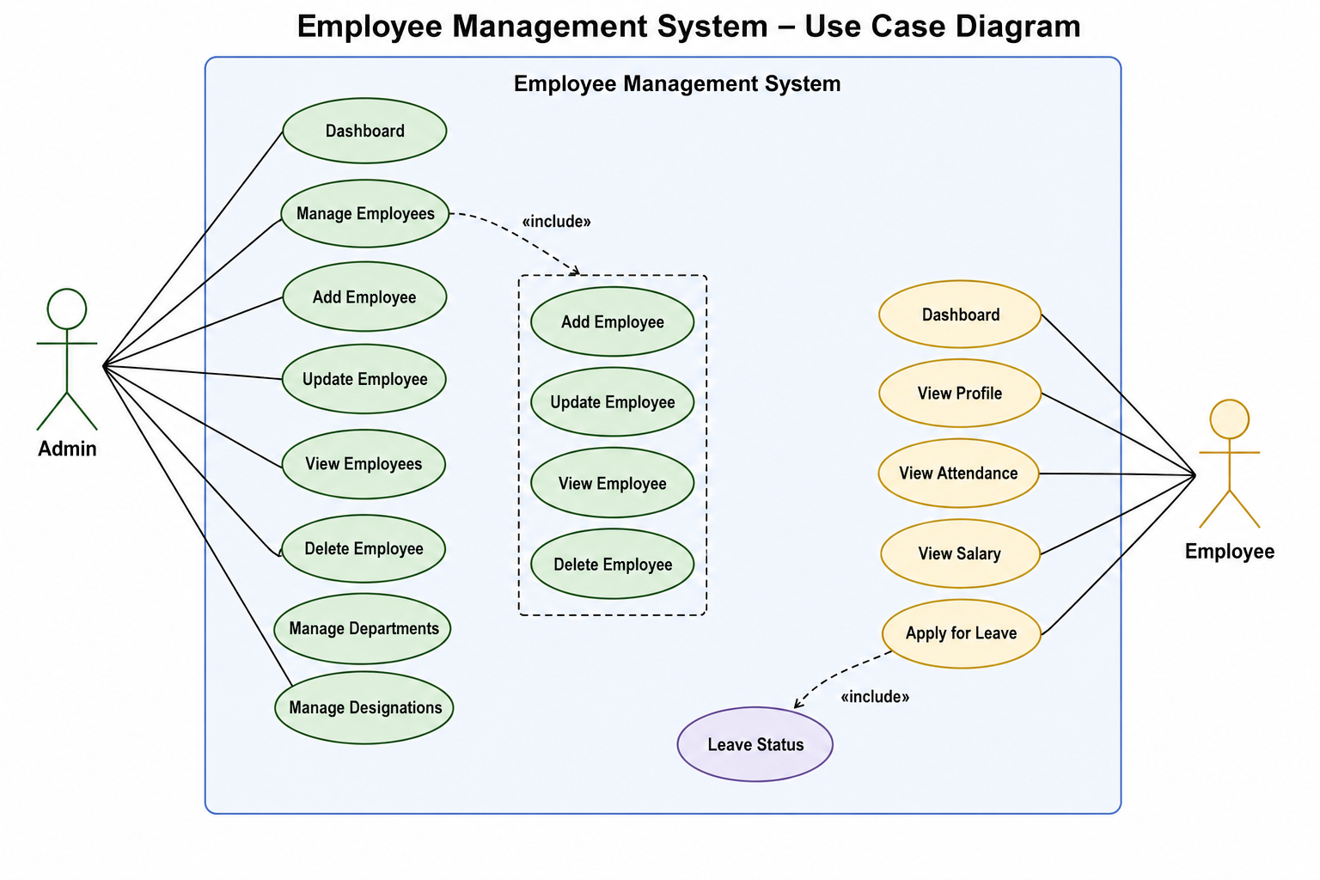
Fig: 3.1

3.2) System Flowchart Diagram:

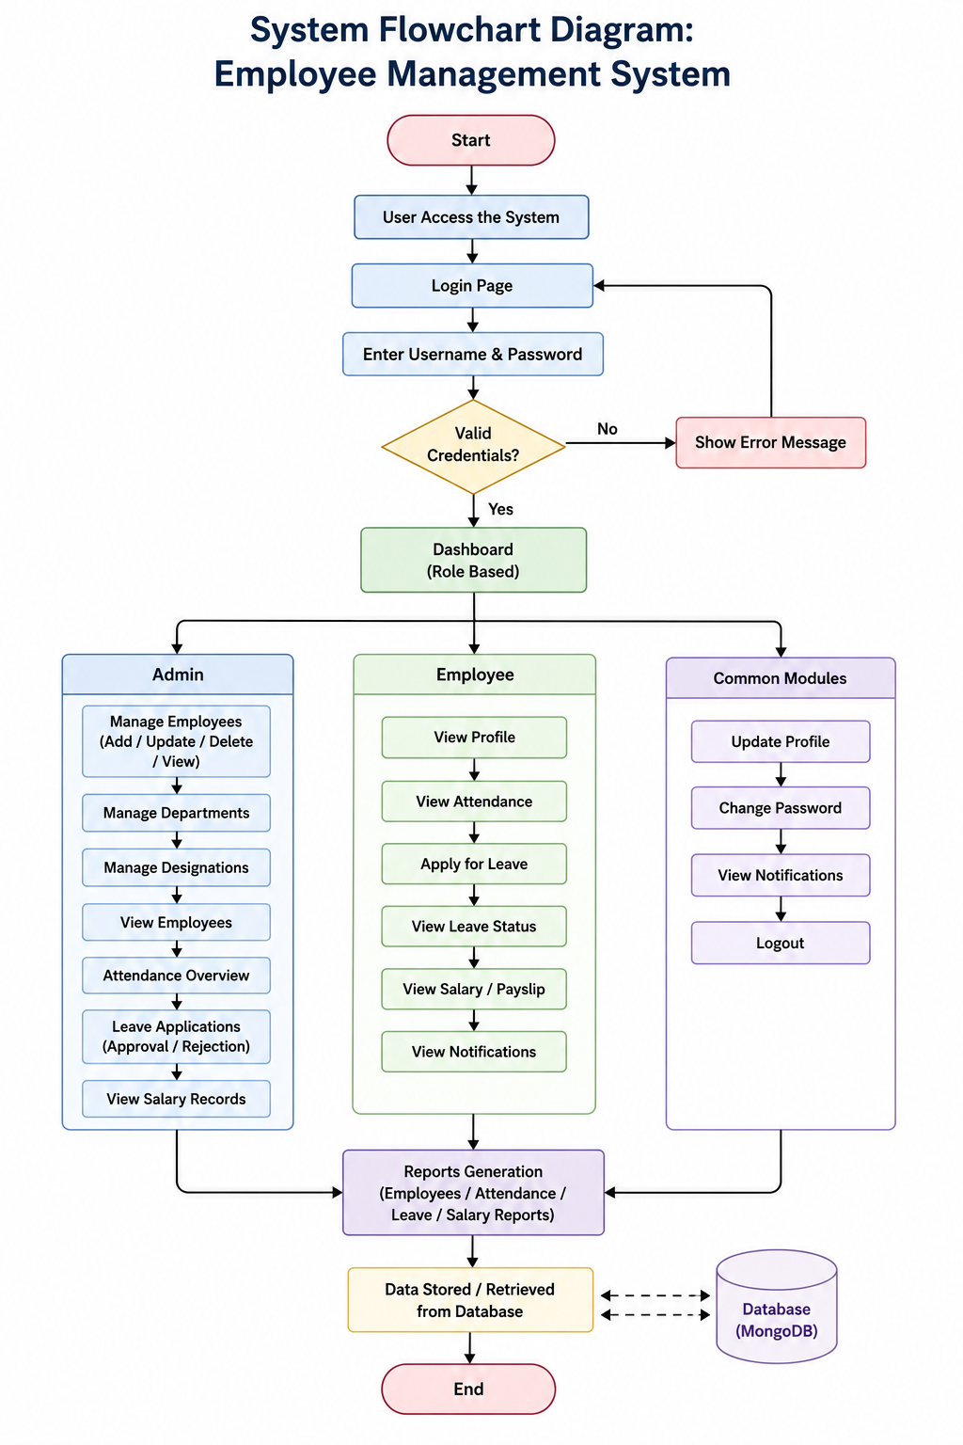

Fig: 3.2

3.3) UML Class Diagram:
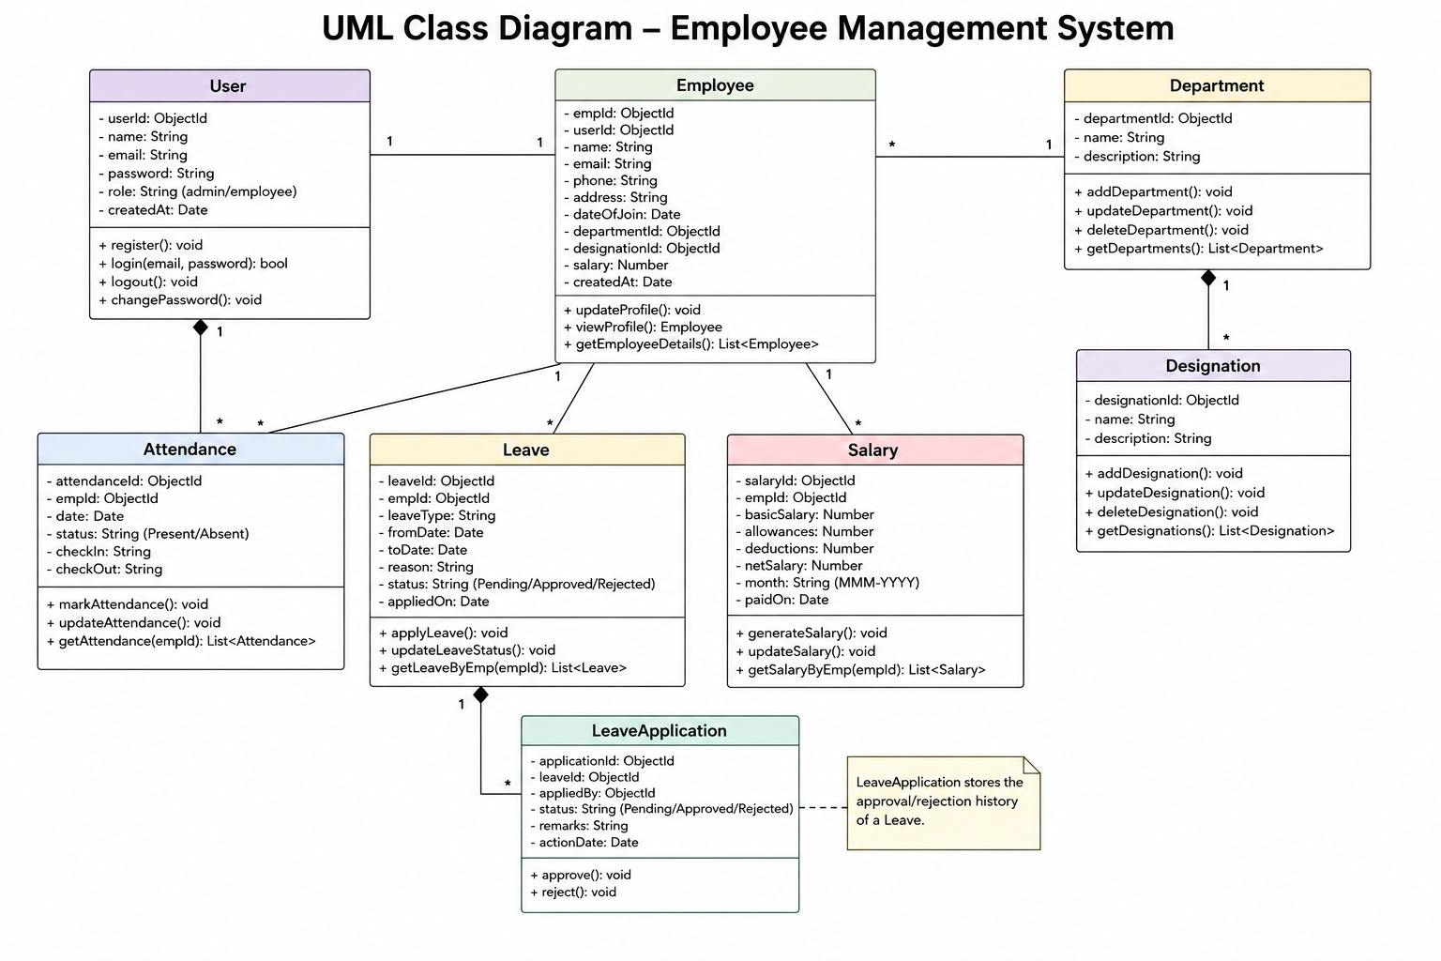

Fig: 3.3

Implementation and Results
Implementation
- The Employee Management System was developed using full stack web technologies to provide an efficient and secure employee management platform.
- The frontend of the application was created using React.js, HTML, CSS, and JavaScript to build a responsive and user-friendly interface.
- The backend server was developed using Node.js and Express.js to handle business logic, authentication, and API requests.
- MongoDB was used as the NoSQL database to store employee records, attendance details, salary information, and leave data securely.
- RESTful APIs were implemented for smooth communication between the frontend and backend systems.
- JWT authentication and role-based access control were integrated to ensure secure login and authorized access to the system.
- CRUD operations were implemented to allow administrators to add, update, view, and delete employee records efficiently.
- Modules such as employee management, attendance management, leave management, and salary management were integrated successfully into the application.
- The system was tested for functionality, security, and database operations to ensure reliable performance.
- Finally, the application was deployed as a web-based system accessible through different devices and web browsers.

Results
- The system successfully automated employee management processes and reduced manual paperwork.
- Employee records could be stored, updated, and retrieved quickly and accurately through the centralized database.
- The implementation of authentication and role-based access improved data security and prevented unauthorized access.
- The leave management process became faster, more transparent, and easier for both employees and administrators.
- The system minimized human errors and data duplication compared to traditional methods.
- Administrators were able to manage employee information efficiently using CRUD operations.
- Employees could easily view their profiles, attendance records, salary details, and leave status online.
- The responsive interface improved accessibility from desktops, tablets, and mobile devices.
- Automated workflows reduced administrative workload and saved organizational time and resources.
- Overall, the Employee Management System improved productivity, data accuracy, communication, and operational efficiency within the organization.

5. Coding

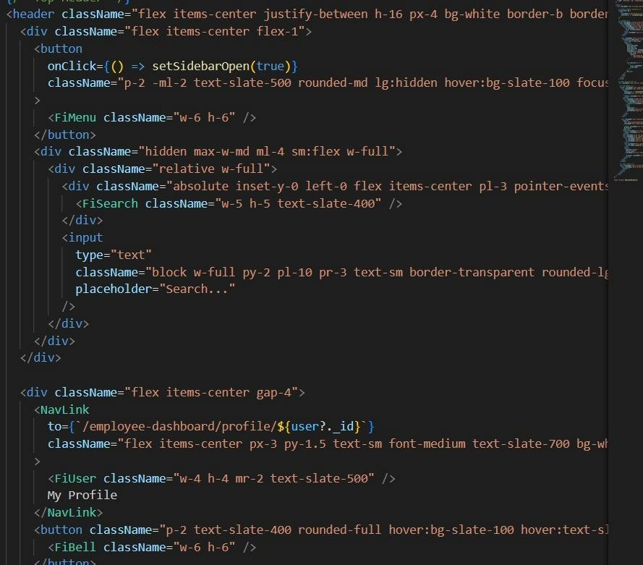

6. Prototype Photographs for User Side

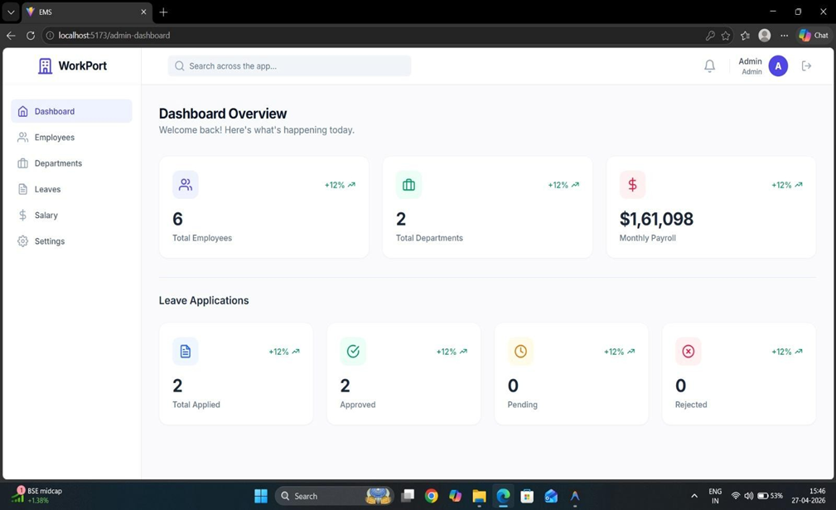

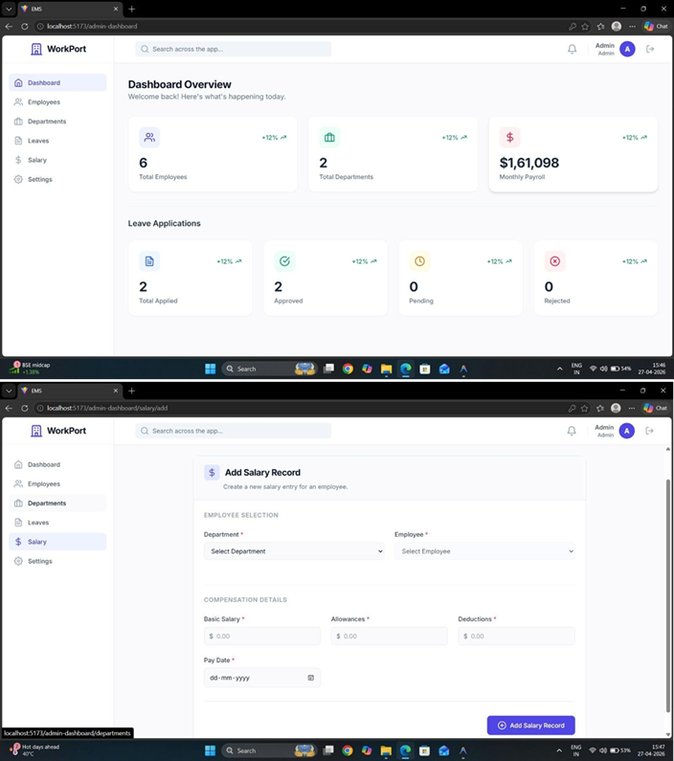

7. Conclusion and Future Work
Conclusion
The Employee Management System is an efficient web-based application developed to simplify and automate employee-related operations within an organization. The system successfully replaces traditional manual methods of managing employee records with a secure and centralized digital platform. By integrating frontend technologies, backend services, RESTful APIs, and MongoDB database management, the application provides smooth and reliable management of employee information.
The system allows administrators to manage employee records efficiently through CRUD operations, while employees can securely access their profiles, attendance details, salary information, and leave status. Features such as authentication, role-based access control, leave management, and attendance tracking improve security, transparency, and workflow efficiency. The implementation of the system reduces paperwork, minimizes human errors, improves data accuracy, and saves administrative time. Overall, the Employee Management System enhances productivity and provides a modern solution for workforce management in organizations.

Future Work
- The system can be enhanced by integrating biometric attendance systems for automatic attendance tracking.
- Mobile application support can be added to improve accessibility for employees and administrators.
- Advanced analytics and reporting features can be implemented for better decision-making and performance analysis.
- AI-based employee performance evaluation and recommendation systems can be integrated in the future.
- Cloud deployment can be used to improve scalability, backup, and remote accessibility.
- Email and SMS notification services can be added for leave approvals, salary updates, and announcements.
- Payroll automation and tax calculation features can be integrated into the system.
- Multi-language support can be added to make the application more user-friendly for different regions.
- Enhanced security features such as two-factor authentication and data encryption can be implemented.
- Integration with other HR and organizational management systems can further improve the overall efficiency of the platform.

